ETPS@Home R15 Learner Pack
Child’s Name: | Class: | Year Level: | Date Started:

This Home Learner Pack is designed as a suggested plan by ETPS staff as to how you may be able to support your child during this time at home. The learning tasks are designed to be completed with support, while encouraging independence where possible. I offer this resource to you as a guide. I understand and appreciate that not all families can work under the same set circumstances as such this resource is offered as a guide. I encourage families to utilise resources provided in your child’s Home Learning Pack and Learning Task Boxes, along with any resources you have at home.

Try to complete 3 Literacy, 3 Numeracy and at least 2 Life Skills Activities from the Learning Grid each day. Refer to the Learning Grid to choose your task.
 | Week 1 |  |  |  |  | Week 2
 | Mon | Tue | Wed | Thu | Fri | Mon | Tue | Wed | Thu | Fri
Literacy
Numeracy
Life Skills
End of week check | Have I shared at least 3 pieces of learning to Seesaw each week?  If not, please take some photos of your learning and upload to Seesaw so I can stay connected with your learning.

R15 Learner Pack

How do I contact my child’s teacher?

Preferred communication Method:

Contact your teacher via Seesaw using the ‘Message’ Function

If your child is working from home:
Please understand that teachers are still teaching within the classroom and will respond to messages as soon as they are able.

If the school is requested to close:
You will receive information via SMS, Skoolbag and Email.
Your child’s teacher may contact you via the preferred contact method listed above.

Secondary contact information

Assunta Alfano
Assunta.alfano330@schools.sa.edu.au

Literacy Activities
Sing or say your ABCs  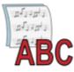 | Visit Reading Eggs and complete a lesson  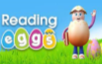 | Read for 15 minutes | Write all UPPERCASE letters of the alphabet.  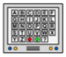
Visit VOOKS to listen to a story | Do a literacy activity of your choice for 10minutes | Find letters on different household items and record them  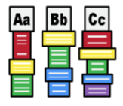 | Draw a picture from your favourite story.  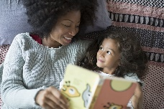
Find your favourite 5 toys and describe them to Mum/Dad  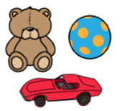 | Practice reading sight words | Write your full name 10 times. Can you write them in different colours? | Practice writing some sight words
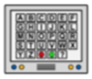  Write all lowercase letters of the alphabet.  Can you write them backwards from Z to A. | Look around the house and write as many words as you can see. | Draw something from your kitchen cupboard.  Copy the label on the product. | Write your teacher’s a letter to give them when you go back to school.
R15 Learner Pack

R15 Learner Pack

Numeracy Activities
Write your numbers 1 - 20 | Count to 20 three times  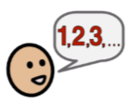 | Count 10 different items in your house. How many of each? | Count the number of shoes and socks that you have. How many pairs?  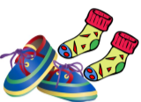
Count by 5s to 100  Colour on the 100s chart  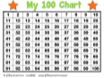 | Write your numbers  20-40 | Use coins to make 15 cents, 25 cents, 45 cents, 65 cents, $1.00  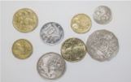 | Complete a lesson on Mathseeds  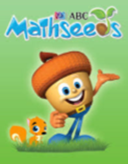
Count your toys. How many dolls? Cars? Trains? Dinosaurs?  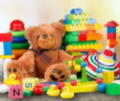 | Write a number, 1-10. Make collections of that number using objects or by drawing circles or lines. Complete for numbers 1-10.  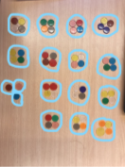 | Using the blocks build towers increasing by 2 and record. | Write your numbers 1-20
Using pop sticks make groups representing 8, 10, 12, 14  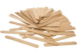 | Complete a lesson on Mathseeds | Write as many numbers as you can. Can you get to 20/50/100? | Count by 10s to 100  Colour on the 100s chart  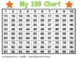
Write a number, and then count on from that number | Using pop sticks solve simple addition problems  (2+4, 5+6, 11+3 then make up some yourself)  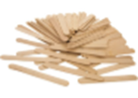 | Complete a lesson on Maths seeds  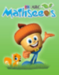 | Using pop sticks, solve simple subtraction problems  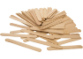  (20-2, 18-5, 5-4)
Using blocks build towers  5, 10, 15, 20 tall | Draw a picture of your family in order from shortest to tallest  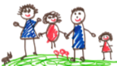 | Count by 2s to 100  Colour on the 100s chart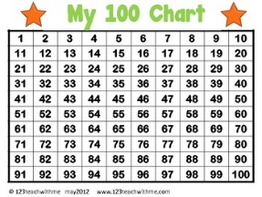 | Using blocks build towers for 6, 12, 16, 20
R15 Learner Pack

Life Skills Activities
Sweep the floor  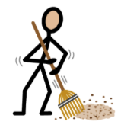 | Help put the dishes away | Find the ingredients for dinner  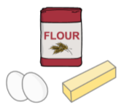 | Do some gardening  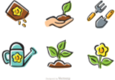
Set the table  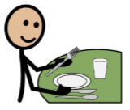 | Do a life skills activity of your choice for 5-10minutes  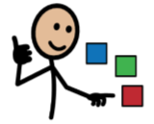 | Have a conversation with a friend/family member  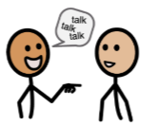 | Match and your fold socks  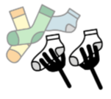
Find 5 numbers written around your house  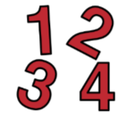 | Fold towels  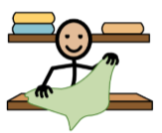 | Help put groceries away  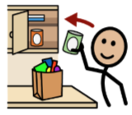 | Help make a snack or dinner  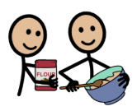
Vacuum the floor  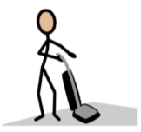 | Load the dishwasher  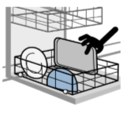 | Make your bed  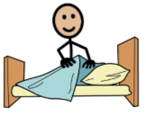 | Help fold laundry and put items away  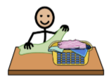
Make your own breakfast  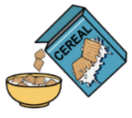 | Put away your toys | Unload the dishwasher | Clean off/wipe down the table after a meal  